A close up of a piece of paper

Description generated with high confidence

CERTIFICATE of DEDICATION

*This certifies that*

**ESAHMARC E. MADANDOS**

*WAS DEDICATED TO GOD*

At Fundamental Baptist Mission, Purok 2, Villangit, Sibagat, Agusan Del Sur.

On the 6th day of April in the year of 2025.

Father : Esaganie H. Mabandos

Mother : Mabet L. Engyo

Birthday: April 18, 2020

Officiated by: Pastor Elven B. Lumalad

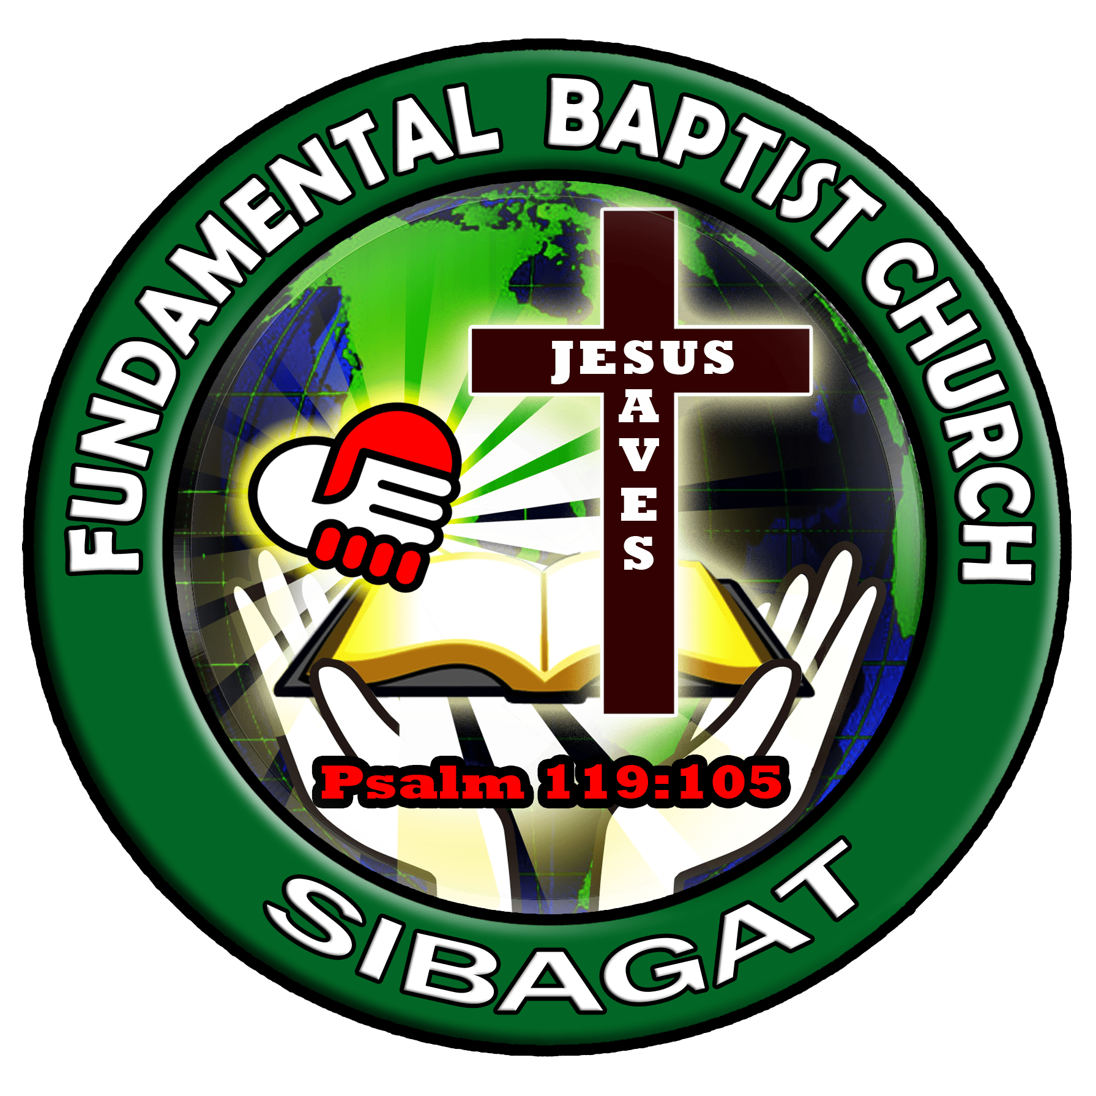



*“Let the little children come to me, and do not hinder them, for the Kingdom of God belongs to such as these.”*

*Mark 10:14 (NIV)*